Assignment No. 09

Roll No. SC55 - Shreyas Chavhan

===================================================

# File Handling in C++

## Problem Statement -

Assignment No. 9 -

Write a C++ program that creates an output file, writes

information on it, closes the file and open it again as an input

file and read the information from the file.

## Theory -

Stream:

A stream is a sequence of bytes. It acts as source from which the input data can be

obtained or as a destination to which the output data can be sent.

1. Input Stream

Input Streams are used to hold input from a data producer, such as a keyboard, a

file, or a network. The source stream that provides data to the program is called

the input stream. A program extracts the bytes from the input stream. In most

cases the standard input device is the keyboard. With the cin and “extraction”

operator ( &gt;&gt;) it is possible to read input from the keyboard.

2. Output Stream

Output Streams are used to hold output for a particular data consumer, such as a

monitor, a file, or a printer. The destination stream that receives data from the

program is called the output stream. A program inserts the bytes into an output

stream. By default, the standard output of a program points at the screen. So

with the cout operator and the “insertion” operator (&lt;&lt;) you can print a message

onto the screen.

iostream standard library provides cin and cout methods for reading from standard

input and writing to standard output respectively.

file handling provides three new data types:

Data Type Description

ofstream -

This data type represents the output file stream and is used to

create files and to write information to files.

ifstream -

This data type represents the input file stream and is used to read

information from files.

fstream -

This data type represents the file stream generally, and has the

capabilities of both ofstream and ifstream which means it can

create files, write information to files, and read information from

files.

## Code -

|  |
| --- |
| /****************************************************************  Assignment No. 9 -  Write a C++ program that creates an output file, writes  information on it, closes the file and open it again as an input  file and read the information from the file.  ****************************************************************/  #include <iostream>  #include <fstream>  using namespace std;  int main()  {  fstream file;  file.open("sample.txt",ios::out);  if(!file)  {  cout<<"Error in creating file!!!"<<endl;  return 0;  }  cout<<"File created successfully."<<endl;  //write text into file  file<<"ABCD.";  //closing the file  file.close();  //again open file in read mode  file.open("sample.txt",ios::in);  if(!file)  {  cout<<"Error in opening file!!!"<<endl;  return 0;  }  //read untill end of file is not found.  char ch; //to read single character  cout<<"File content: ";  while(!file.eof())  {  file>>ch; //read single character from file  cout<<ch;  }  file.close(); //close file  return 0;  } |

Roll No. SC55 - Shreyas Chavhan

===================================================

## Output -

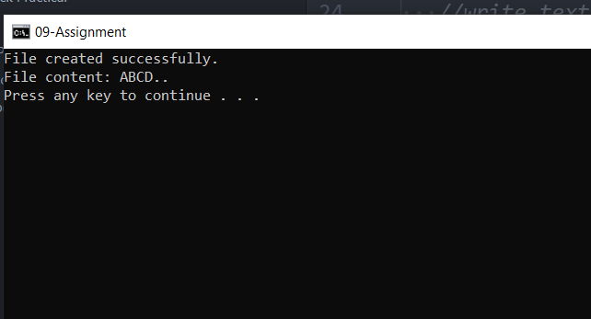

===================================================

Roll No. SC55 - Shreyas Chavhan